When I enable "Copy data to workspace" and give a "Path to folder" which does not exist, I get a null pointer exception:
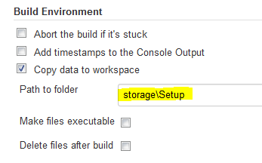

Console output (if directory doesn’t exists)
| Started by user anonymous
| Building remotely on dem6894 (RanorexTestPC) in workspace d:\JenkinsSlaveRoot\workspace\Debug
| FATAL: null
| java.lang.NullPointerException
| at hpi.CopyDataToWorkspacePlugin.saveNames(CopyDataToWorkspacePlugin.java:164)
| at hpi.CopyDataToWorkspacePlugin.setUp(CopyDataToWorkspacePlugin.java:92)
| at hudson.model.Build$BuildExecution.doRun(Build.java:154)
| at hudson.model.AbstractBuild$AbstractBuildExecution.run(AbstractBuild.java:536)
| at hudson.model.Run.execute(Run.java:1718)
| at hudson.model.FreeStyleBuild.run(FreeStyleBuild.java:43)
| at hudson.model.ResourceController.execute(ResourceController.java:89)
| at hudson.model.Executor.run(Executor.java:240)

Console output (if directory does exists)
| Started by user anonymous
| Building remotely on dem6894 (RanorexTestPC) in workspace d:\JenkinsSlaveRoot\workspace\Debug
| Collecting metadata...
| Metadata collection done.
| Finished: SUCCESS

I traced to problem back to line 164 of Code.java
-|this.copiedFiles = new String[children.size()];
+|if(children== null)
{
System.out.print ln(“Path described doesn’t exist ”);
.....
/ throw exception (“Path described doesn’t exist ”);
}

